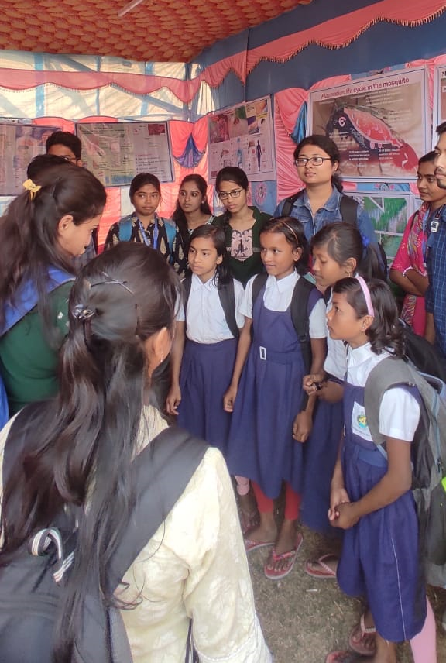
Fig. Sriniketan Sericulture Unit & Makrampur Harijan Primary School, Birbhum
Date: 19.03.2024

