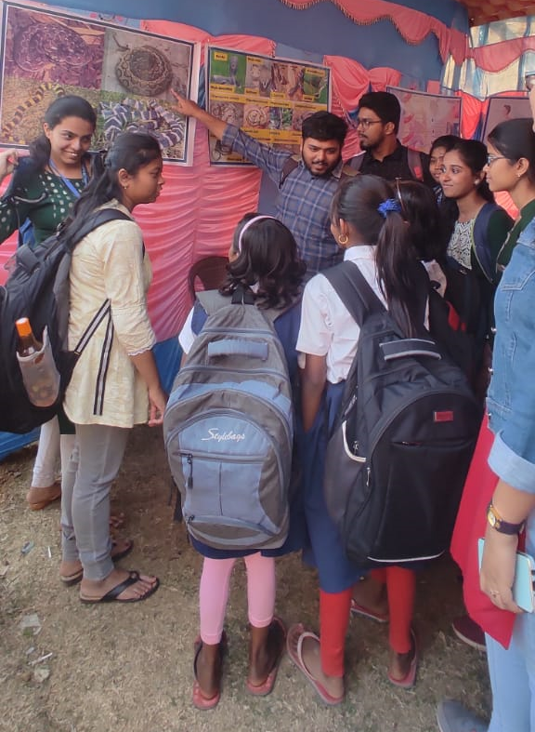
Fig. Tarakeswar Degree College 2. ‘Agricultural Fair’ held at Atpara, Purba Bardhaman, West Bengal Date: 29.01.2024

