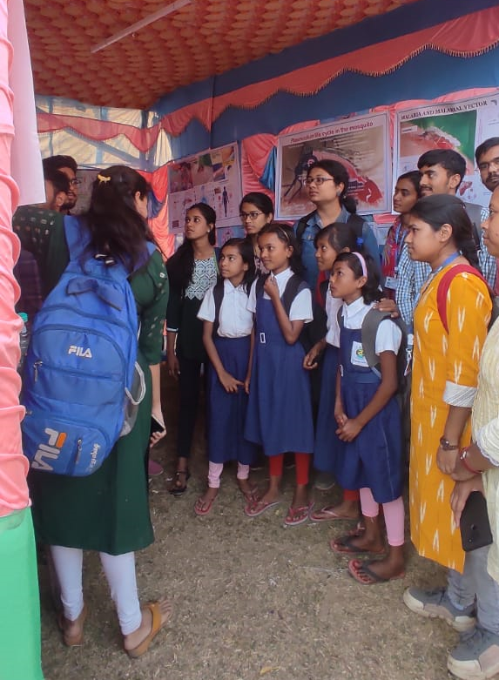
Fig. ‘Agricultural Fair’held at Atpara, Jaragram, Purba Bardhaman, West Bengal
Date: 08.02.2023

