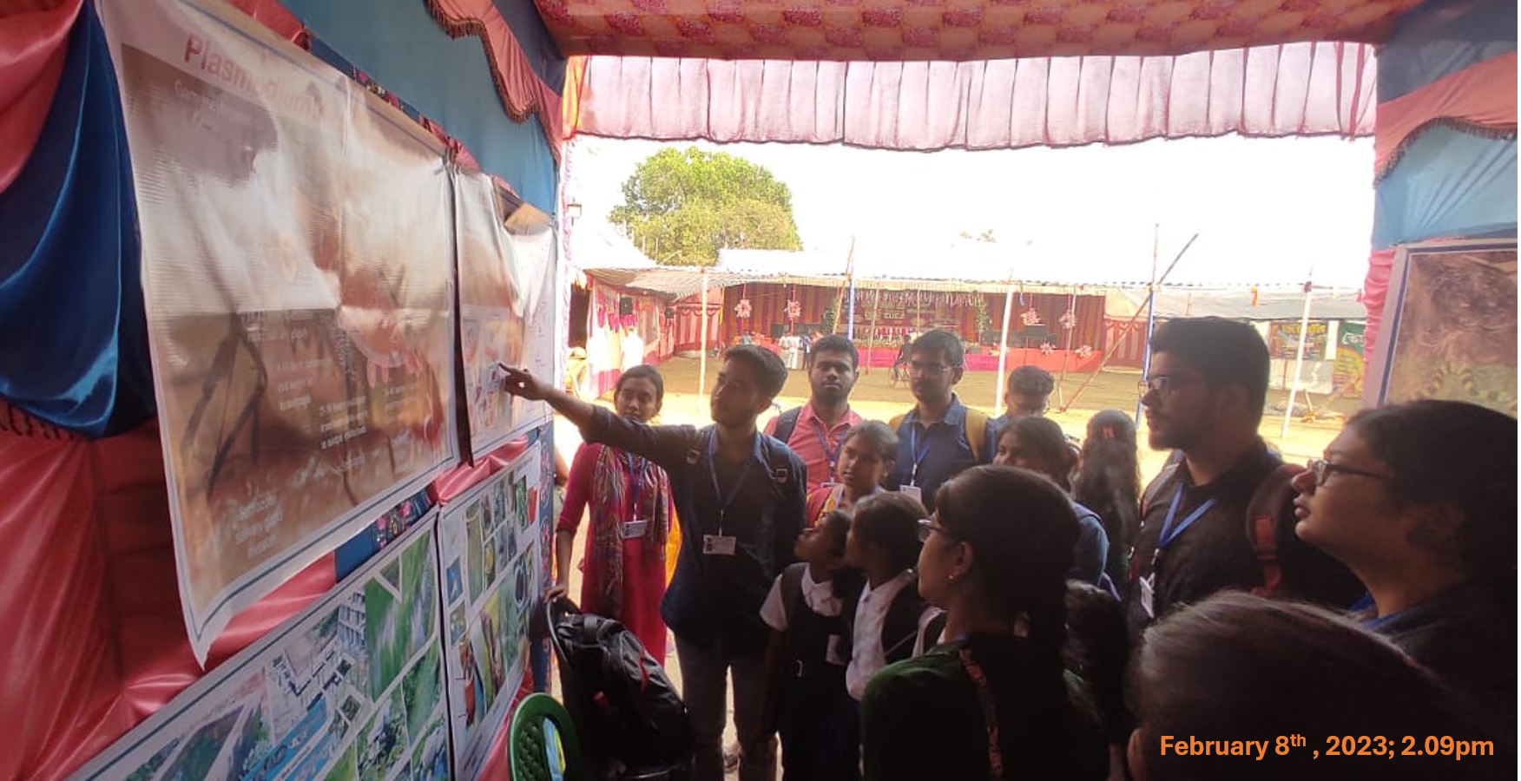
Fig. To provide hands-on training and awareness on scientific fish farming and vermicomposting

