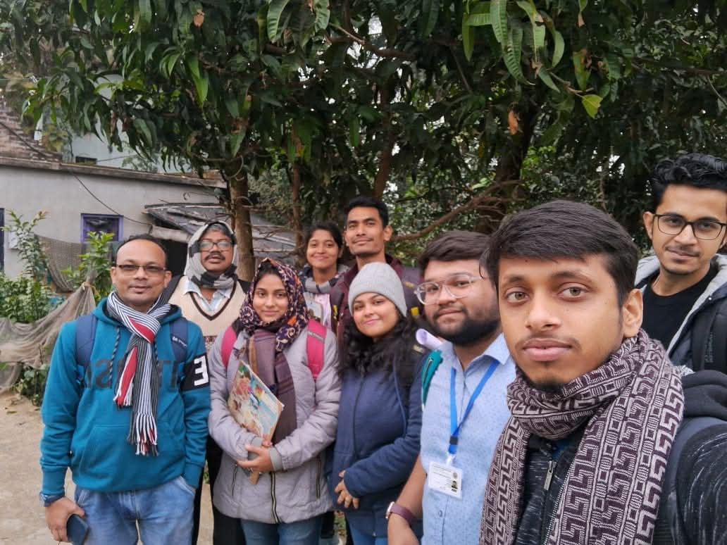
Fig. Soaial Outreach in school and village at Sarangpur, Guskara, West Bengal-713128

